**ONLINE NURSERY PLANT SHOPPING WEBSITE**

**A PROJECT PROPOSAL**

**BY**

**GROUP 69**

**CHAPTER ONE**

**Introduction**

* 1. **Background of the Studies**

Online nursery plant shopping website describe an e-commerce website where the customers can purchase the plants and flowers and vendors can add the items for sale online. This helps the user to surf through various types of indoor and outdoor plants and flowers available in Nigeria. This saves user time as the website is accessible from any location using internet connection. The detailed information about indoor plants and outdoor plants distinguishes the purchase of the items according to the customer willingness. The gardening tips are elaborated with the real-time service. This project work also focuses on providing the job to the needy ones for collecting and delivering the products. The admin maintains the vendor information related to the products and monitors the stock availability. If the product is out of stock, then the admin can directly contact the vendors. In addition to this, a FAQ page is given such that customers can write their queries.

The notion that internet users has grown rapidly in just a couple of years lead us to believe that internet commerce is expected to boom as well in the near future. In order to justify internet commerce and internet shopping, an online shopping system permits a customers to submit online form to order plant online or purchase any kinds of flowering plants from vendors online for items or services that serve both walk-in customers and online customers.

The online nursery plant shopping system present an Online display of an order cut-off time and an associated delivery window for items selected by the customers. The Online Shopping is a web based application intended for online retailers and end users. The main objective of this application is to make searching, viewing and selected of a product easier and convenient. It contains a sophisticated search engine for uses to search for products specific to their needs.

The search engine provides an easy and convenient way to search for products where users can search for a product interactively and the searching engine would refine the products available based on the users inputs, the users can then view the complete specification of each product.

* 1. **Statement of The Problem**

The level of issues and time consumption at which customers face while sorting for nursery plant is overwhelming and the need for computerized system needed to be considered, visiting multiple nurseries to find the right plant to suit your needs can get tedious and end up eating up your entire weekend. The online nursery plant application is an online nursery that allows you to shop for plants from the comfort and conveniences of your homes.

Using this application, customers can view all the available plants with details such as the plant's cost, level of maintenance required, watering schedule, etc.

**1.3 Aims and Objective of the Study**

The Aim is to design a web application software that will allow users to order nursery plant online remotely and keep track of it progress till delivery date.

The objective of the project includes:

1. The dataset of both the users and nursery plant will be generated upon registration on the site.
2. In the front-end development modern technologies such as HTML, CSS, and JavaScript will be employed to create an interactive UI and UX as well as Django which is a Python web framework will be employed in developing the back-end
3. In storing and retrieval of the collected dataset; MySQL which is an open-source relational database, will be used as the database technology.
4. Vital testing will be carried out in ensuring the efficacy of the research work

**1.4 Scope of the Study**

In this project, an online nursery plant shopping will be designed to make it convenient for users to search and order for their plants easily and the Kaduna Colab technology nursery plant hub will be taken as a case study to enable customers to order for any kinds of nursery plant and delivered accordingly and also to reduce the long queues of customers encounter while they visit nursery plant physically.

The following things are among other things that are discussed and what the software would handle:

1. About the nursery plant shopping
2. The kinds of nursery plants currently available and their price tag
3. Online nursery plant purchase
4. Categories of nursery plants available
5. The current season for better nursery plants available

**1.5 Limitations of the Study**

During this research work, below are some limitations that

Were encountered:

1. Inadequate information from the staff and Kaduna Colab technology nursery plant hub due to the heavy workload which occurs using the manual system of shopping
2. Not all the data were gotten using the primary source
3. Some information was gotten through the internet and searching for information was difficult due to some network problems.
4. Due to these reasons, the researcher may lack vital information about shopping and may also have lapses in this work.

**1.6 Significance** **of Study**

Many people nowadays are using the web to shop for a wide variety of nursery plant items, the significance of the online shopping system includes the followings:

1. Online Shopping System is an incredible convenience.
2. It is always easy when it comes to accessing customer review
3. The choice of online Shopping is infinite.
4. It price is always a comparison

**1.7 Project Organization**

The project is divided into five chapters. The outlines are presented below:

**Chapter One: Introduction**

Chapter one introduces this project work, the background of the study, the statement of the problem, the aim and objectives, the scope of the study, limitations of the study, the significance of the study, project organization, and the definition of terms.

**Chapter Two: Literature review**

This chapter focuses on the literature review, and the contributions of other scholars on the subject matter being discussed.

**Chapter Three: Methodology and Design**

This chapter is concerned with the presentation of the results of system analysis and design. It presents the research methodology used in the development of the system to facilitate an understanding and effective future implementation of the system.

**Chapter Four: System Implementation Evaluation**

This chapter describes the system implementation and documentation, analysis of modules, and system requirements for implementation.

**Chapter Five: Summary, Conclusion, and** **Recommendation**

The chapter provides a summary of major findings, conclusions, and recommendations based on the study conducted.

**1.8 Definition of Terms**

1. **Shopping:** Is the processing of browsing and purchasing items in exchange of money
2. **SECURITY:** Its objective are to establish rules and measures to against attacks over the internet
3. **SHOPPING CHART:** A chart supplied by a shop, especially supermarket, to use by customers inside the shop for transport of merchandise to the check- out counter during shopping
4. **DATABASE:** A systematized collection of data that can be access immediately and manipulated by a data processing system for a specific purpose
5. **E-COMMERCE:** Electronic commerce refers to the process of marketing, buying and selling of product and services online.
6. **ROBUSTINESS:** The ability of a compute to cope with errors during execution or the ability of an algorithm to continue to operate despite abnormalities in input calculation etc.
7. **ONLINE:** An online is a condition of connecting to a network of computers of other devices. The term is frequently used to describe someone who is currently connected to the internet.

**CHAPTER TWO**

**Literature Review**

**2.0 Introduction**

Nowadays, the internet is not only a networking media but it is also used as a means of transaction for consumers at global market for any kinds of market productivity.

The internet is becoming popular as it is a virtual place where people share their ideals, build communities, shape the future democratically and promote a new way of doing business. The internet is the world’s biggest shopping mall that allows enterprises to do their business with low cost involved, yet covering global market. The usage of internet has grown rapidly over the past years and it has become common means of delivering and trading information, services and goods globally.

**2.1 Review of Related Past Work**

Halder, P.P., Kaium, M., Abdul, H. and Islam, M., (2021). “*E-Commerce Based Agricultural Web Application.”*  discussed the main aim is for farmers to sell or purchase their produced items inside at a good cost. Sabuj Chashi is mainly focusing on selling or purchasing rice at a lowest but acceptable price compared with the government price. The platform also has the facilities of buying or selling of green plants & plantation related products. The main purpose is to ensure the food at a lowest cost to everyone & also to ensure a greener Bangladesh.

Syafitri, A.I. and Nasrullah, N., (2020). Study of Landscape Plant Nursery in Bogor Regency for Development of Plant Supply Information System. has assessed features of the landscape plant nursery in Bogor Regency. Based on correlation analysis results, it was found that plant stock was influenced by nursery area, type of nursery, and nursery utilities. The purpose of this was to examine the characteristics of nursery including aspects of plant diversity, physical, production, and marketing. Besides, it also analyzes the factors which influence plant products in the nursery and to create a prototype website for online buying and selling plants. So, the success in the sales can be achieved by creating a website as a functional media that can provide the information on stock and price of plants at the nurseries in Bogor Regency.

M. Nakamura, T. Kajiyama and N. Ouchi, "E-Commerce Website Design for Expanding Knowledge and Interests of Potential Buyers," (2019), they have presented a design for e-commerce websites that aims to expand the product knowledge and interests of potential buyers. The user can browse product information from three viewpoints including product attributes, attribute examples, and detailed information about each attribute.

D. Bhargava, P. Mishra and A. Mishra, "Designing an Expert System for Online Shopping Cart Management,", *(2018) Amity International Conference,* the authors have given the Knapsack problem can be implemented in e-commerce websites as well, for an easy shopping experience for those users who have a fixed budget. The online customers can fix their budget before shopping, and fill the shopping cart by choosing items that are sorted as per the least price and/or the most relevance or rating. Items from the different categories that the shopper wants to buy from, can be clustered automatically by their popularity into baskets.

Haque, M. and Talukdar, T., 2017. *“Let's Make Our City Greener: Web Based Project.”*, to provide a Web-based e-commerce site Project that will help the people for gardening in their home rooftop or balcony. This Web-Based application gives the opportunity to users to know about gardening anytime from anywhere. The main motive was to achieve a natural city with tree plantation and also our benefits. It not only benefits us but also for the environment.

**2.2 Review of online shopping system**

However, there are so many people all over the world who used the internet to shop for goods and services. According to AcNelsen (2007), more than 627 million people in the world shop online. Many online shopping websites over the internet spread like virus that broaden people choice in terms of products ranging from clothes, shoe, jewellery, electronics and even gadgets. People are very much likely to shop online rather than going to visit physical location, because items that are available in online system are very much accessible.

According to Limacaoca (2000), Filipinos experience themselves the convenience and accessibility of online shopping. That is why online shopping has become an importance part of Filipinos’ life styles as well as many people live. Online shopping g popularity continually increases over time and it appears to be no signs of slowing down.

According to Rafael (2006), online shopping popularity has much more usefulness it offers to people. It is more than just shopping but creating the whole new life styles of community access to entertainment, information and much more. There are myriad of reasons why online shopping is very popular to students and professional.

According to Shwu-ing, (2003), Customers found benefit perception, comprising convenience, selection freedom, information abundance, homepage design and company name familiarity, has a significance relationship with attitude toward online shopping. The main motivation to online shopping is that it is more convenient than to shop in stores. In other word, convenience is the most prominent factor that motivates consumers to shop via the internet, moreover, easy of search; good price deal, good selection, availability, fund impulse, customer services and der selection of retailers are additional reasons why people shop online (Khatibi, Haque and Karim 2006).

**2.3 Types of online shopping cart for nursery plant system**

The different types of online shopping cart system will work for both the existing and new computerize system online. These carts are the best tools users will have if you are starting an online business.

1. **READY-MADE SHOPPING CARTS:** ready-made shopping cart, if customers do not have time to construct his/her own shopping cart system, they may always look for this option, all the user need to do is to choose the design from the ready-made option of the service provider.
2. **CUSTOMIZED SHOPPING CART:** In this system, the website provider have a customize cart for customers to choose custom product or the nursery plant and placed there order directly and system admin will take necessary of each users order
3. **SPECIALISED SHOPPING CART:** With the customers own design if the customer have artistic style, he may always design the shopping cart that he want for his ordering online.

**2.4** **Importance of Nursery Plant Shopping System**

When it seems that the entire world is making it online be it marketing or exposure, online nursery plant shopping lags no behind either. Be it for company decoration or personal use only.

there are various benefits to it as it includes the under listed:

1. The nursery plant purchased by customers are delivered at their convenience and disposal.
2. In the online nursery plant shopping world, the prices of plant are affordable compare to offline shopping.
3. Online shopping is very important because the internet allows for researching avenue (opportunities).
4. It is environmentally friendly; it does not have room for discrimination.
5. Also, in online shopping the choices which customer can get product are amazing.

**2.5**  **Roles of Online Nursery Plant System**

The online nursery plant shopping system plays a vital role as it is designed for convenience, easy and user friendly. Instead of customers waiting on a queue (long line) in stores or searching from store to store and or farm to farm, customers may shop from home simply by clicking on the nursery plant shopping website and navigate through to their order conveniently.

Online nursery plant shopping is also rewarding, many website offers great sales and some websites are even designed as internet bargain stores, such websites make shopping a hassle –free and rewarding experience.

E-commerce has greatly influenced the normal living of the customers who cannot find time to buy their basic necessity offline. It is also the way through which many customers (people) have gotten different benefits and for this purpose the internet has widen up the scope of using various internet functions. Many Ecommerce companies provide good shopping cart which is very useful to both people and organization or online customers and manufacturers.

2.**6 History of Online Shopping System**

Online shopping system was invented in UK in 1979 by Michael Aldrich. The pioneer of online shopping (Michael Aldrich) is an English entrepreneur who connected his system to a modified domestic TV to a real-time transaction processing computer Via a domestic telephone line. In March 1980, he went on to launch Redifon’s offices Revolution, which allowed consumers, customers, agent distributors, suppliers and services companies to be connected online to the corporate systems and allow business transactions to be completed electronically in real- time.

During the 1980’s he designed, manufactured, sold installed, maintained and supported many online shopping system, using video text technology. These systems which also provided voice response and handprint processing predate the internet and the World Wide Web, the IBM PC and Microsoft Disk Operating system (MS-DOS), and were installed mainly in UK by large corporations.

The first World Wide Web server and browser, created by Tim Berners -Lee in 1990, opened for commercial use in 1991. Thereafter, subsequent technological innovations emerged in 1994. Online banking the opening of an online pizza shop by pizza Hut, Netscape’s SSL V2 (Secured Socket Layer version2) encryption standard for secure data transfer, and inter shops first online shopping system. Immediately after, Amanzon.com launched its online shopping site in 1995.

**2.7 Purpose of Online Shopping System**

1. E-Commerce is a rapidly growing business section across the world and provides interesting expansion opportunities for retail businesses. However, different consumer’s attitudes across borders create barriers for expansion and subsequent there is a need to study these differences. The purposes of online shopping include the followings:
2. To examine potential differences between customers attitudes and online shopping intensions when purchasing apparel online.
3. To identify factors influencing consumers intention to use internet when buying/purchasing products or good online.
4. To see how impulse buying could manifest itself online by comparing the offline and online medium through visual enquiry, and build on the already extensive interaction of offline impulse buying.

**2.7 Characteristics of Online Shopping**

In order to compete against online shopping, it is clear to us that retailers are focusing on shopping centers that provider the following favorable characteristics:

1. High productivity
2. Growth potential
3. Efficient layouts
4. Positive competitive dynamics
5. High shopper traffic

These characteristics are critical for manufacturers to ensure that their shopping centers performs ultimately, manufacturers must have a clear understanding of the value they are creating. If the manufacturers can satisfy retailers on the above characteristic the will have a strong shopping Centre.

**CHAPTER THREE**

**Methodology and Design**

**3.1 Introduction**

Research methodology should be effective enough to ensure fulfillment of the defined objectives through particular components such as techniques of data collecting and design. Methodology is a process of rigorous study or inquiry specifically in order to uncover new fact or information. By combining the aforementioned, it will be possible to create a platform that is extremely reliable, quick, and practical).

**3.2 Methods of Data Collection**

It is crucial to acquire data and facts about the current system before implementing any system since one has to understand what is happening. Two techniques were used to conduct this study.

1. Observation of the Work Environment
2. Documentation

**3.2.1 Observation of the Work Environment**

This strategy was used to collect information and data for this study by observing how the manual system functioned. Through close inspection, the system's obvious flaws were found. The context in which the observation is conducted can be changed in a variety of ways by using the observational technique.

**3.2.2 Documentation**

A secondary form of data acquisition is documentation. Journals, manuals, previous projects, publications, and other sources are used in this approach. This type of data collecting is employed because it provides a foundation for comparison with previous research. This includes the internet, a tool for gathering data. The internet was utilized to find information on topics that seemed challenging or unclear.

**3.3 System Modeling**

A system model is a conceptual model that describes and represents a system. Any interaction between a group of components that work together to accomplish a single goal is referred to as a system. Visual models of the object-oriented software-intensive systems can be made using a set of graphic notation techniques that are part of the Unified Modeling Language, which is employed in this modern system design. Use case diagrams, class diagrams, and activity diagrams are among the UML diagrams used in this new design.

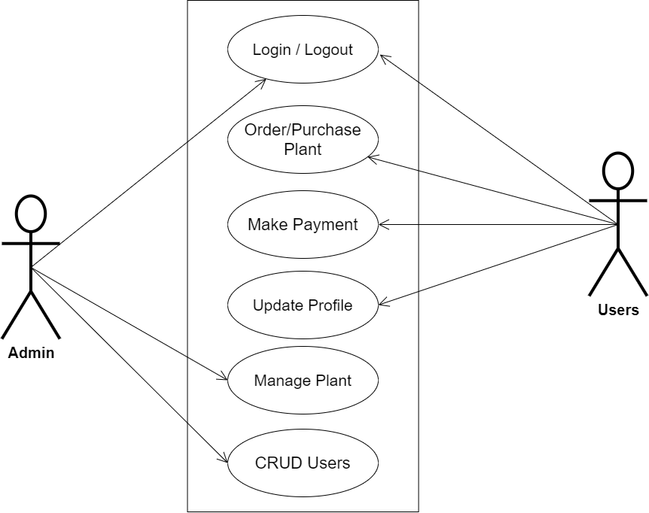

**Fig 3.1 System Use Case Diagram**

**3.3.2 Class Diagrams**

Class diagrams are visual representations of a system's static structure and composition that adhere to the Unified Modelling Language principles (UML). It is one of the most often used UML diagram kinds. Class diagrams make it simpler to explain all of the classes, packages, and interfaces that comprise a system, as well as how these components are interconnected.

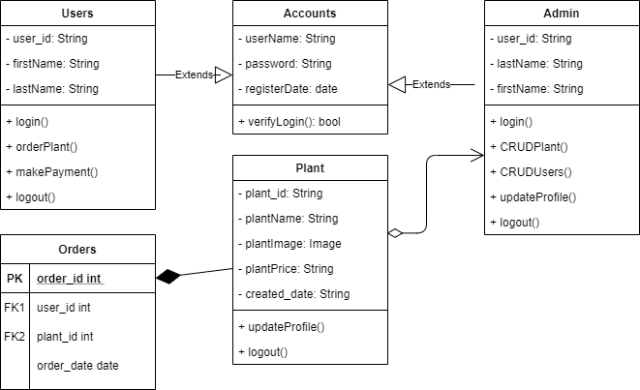

**Fig 3.2 Class Diagram**

**3.3.3 Activity Diagrams**

Similar to a flowchart or a data flow diagram, an activity diagram visually depicts a sequence of events or the flow of control in a system, but it functions more like an advanced version of both.

Login

The process for gaining access to the system is depicted in the diagram below; in order to gain access, the email address and password must be accurate.

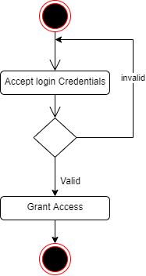

**Fig 3.3 Login Activity Diagram**

**Adding Plant**

The process for adding plant is depicted below, to add a plant one must be an administrator and must be authenticated.

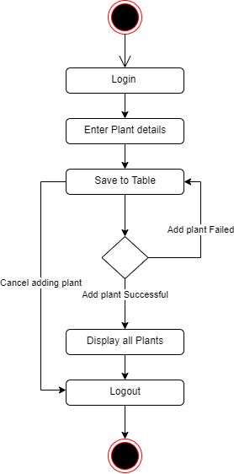

**Fig 3.4 Adding Plant Diagram**

**3.4 Database Design**

The logical explanation of how data is kept in the computer's memory is called input specification. The freedom experienced in using the system, as well as the convenience of retrieving and reading the data and assuring applicability across the internet, make SQL standards essential for ensuring that structured data is uniform and independent of applications. Some of the input specifications employed in this project work are presented below.

i. Users Table: contains basic information about all system users.

ii. Plant Table: contains department course information.

**Table 3.1 Users** **Table input specification table**

|  |  |  |  |
| --- | --- | --- | --- |
| **FIELD NAME** | **DATA TYPE** | **LENGTH** | **DESCRIPTION** |
| Email | String | 150 | User email address |
| Firstname | String | 150 | User first name |
| Lastname | String | 150 | User last name |
| Phone | String | 150 | User phone number |
| user_id | String | 64 | A unique string for identifying users |

**Primary key:** user_id

**Table 3.2 Plant** **Table input specification table**

|  |  |  |  |
| --- | --- | --- | --- |
| **FIELD NAME** | **DATA TYPE** | **LENGTH** | **DESCRIPTION** |
| Plant_title | String | 150 | Name of the plant |
| Plant_price | String | 150 | Price of the plant |
| Plant_image | Image | - | Image of the plant |
| Created_date | String | 150 | Date when the plant was added |
| Plant_id | String | 64 | A unique string for identifying plants |

**Primary key:** plant_id

**3.5 Output Design**

This declares and displays the outcome of the given input. The automated system's output is dependent on its input. The output specification is listed below.

**Table 3.3 Users** **Table input specification table**

|  |  |  |  |  |
| --- | --- | --- | --- | --- |
| **Email** | **Firstname** | **Lastname** | **Phone** | **User_id** |
| XXXX | XXXX | XXXX | XXXX | XXXX |
| XXXX | XXXX | XXXX | XXXX | XXXX |
| XXXX | XXXX | XXXX | XXXX | XXXX |
| XXXX | XXXX | XXXX | XXXX | XXXX |

**Primary key:** user_id

**Table 3.3 Plant** **Table input specification table**

|  |  |  |  |  |
| --- | --- | --- | --- | --- |
| **Plant_title** | **Plant_Image** | **Plant_Price** | **Created_date** | **Plant_id** |
| XXXX | XXXX | XXXX | XXXX | XXXX |
| XXXX | XXXX | XXXX | XXXX | XXXX |
| XXXX | XXXX | XXXX | XXXX | XXXX |
| XXXX | XXXX | XXXX | XXXX | XXXX |

**Primary key:** plant_id

**3.6 Input & User Interface Design**

This displays the pictorial representation of the system interface, the interface is going to be designed in a way that it will be user friendly, responsive and attractive. It will also be well secured such that login will be required to access some level of contents. The designs are aided by a mid-fidelity wireframing tool called Draw.io

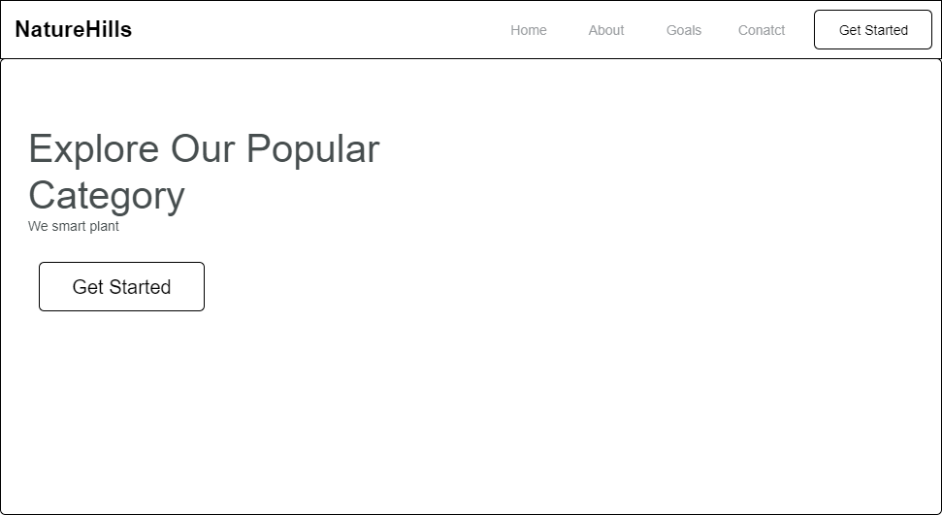

**Fig 3.6.1 Home Page Screen**

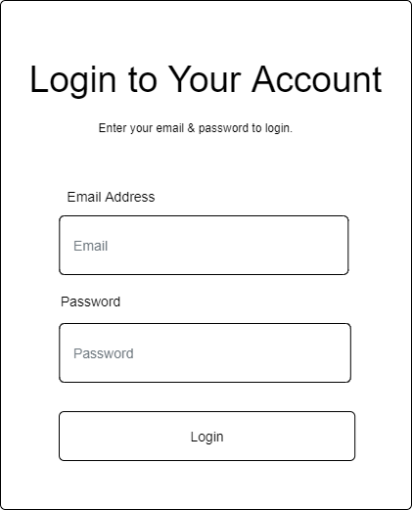

**Fig 3.6.2 Login Screen**

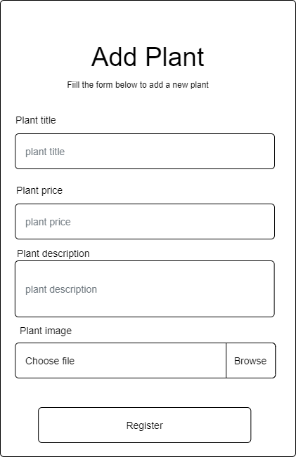

**Fig 3.6.3 Add Plant Screen**

**3.7 System Requirement**

Every piece of software that is created has a pre-set system requirements that it must meet in order to run at its best. However, the system requirements are the bare minimum hardware and software needed for the system's intended operation.

**3.7.1 Hardware Requirement**

System Hardware Requirement Include:

a. Minimum of 8 GB of RAM (Random Access Memory) installed.

b. Minimum of intel core i3 processor.

c. Minimum of 250GB HDD (Hard Disk Drive).

**3.7.1 Software Requirement**

The software requirements include:

a. At least windows 7 OS (Operating System).

b. Python Installation.

c. Vs. Code installation.

d. Browsers include Chrome and Firefox.

**3.8 Choice of Programming Language**

Various types of programming language exist that could have been used in writing this tutorial application but the choices of programming languages used involve HTML5, CSS3, JavaScript, Python (Django) and SQLite. The reasons for choosing these programming languages is that it is a web base applications and require web programming language and are as follows:

1. **HTML** is the bedrock of Web Applications as it is the skeletal framework of a webpage. HTML5 is an updated version of it and it consist of various new tags that enable effective validation of forms and other functions that will assist JavaScript in some of it functions.
2. **CSS3** is the latest version of the Cascading Style sheet that helps style the page and makes it display effectively on the screen of your device.
3. **JavaScript** is a client-side scripting web language that is used for validation of forms and user inputs.
4. **Python (Django)** is a server-side scripting language that enables communication between the server and web page. It usually works with any SQL database to deliver content from the server.
5. **SQLite3:** An open-source relational database.